CAR WASHING USING ANDROID APP

Abstract
Car washing application Project is a mobile application. In-Car Washing app project in Android performed all the operations needed to clean the car successfully by using highly expert and experienced workers. Car wash app is simple and rich feature, It can be used for a vehicle wash reservation system Business owners can manages online using rich feature admin panel without any hassles. Wash Manager is a fully responsive and easy to use. You can also integrate with any existing app by using this Wash Manager. The car wash app system also allows service providers to create customizable reports based on specific criteria. The car wash system has provided business owners with customizable invoice, clean customer record and customer tracking. The car wash system allows quicker customer details retrieval and enables business owners to view in mobile. Such factors are propelling the growth of the vehicle wash management app. Continuous innovations and integration of new technologies in the vehicle wash management system are one of the key trends in the car wash management app.
The car washing management is composed of 2 User Interfaces which are the Admin and the User login. The admin panel is the side of the mobile where the Car Wash app can manage the bookings submitted online. This site requires the users to log in with their credentials to gain access to the features and functionalities of the said side of the system. On the user Site, the possible clients or customers can explore the different services the business. They can also list the prices of the services for each type of vehicle. Customers can simply fill the fields and submit the booking form to send the Car Wash Management an appointment request for their desired services.
Existing System:
The car wash management is previously maintained by manually. If a user needs an appointment for washing their car, they need a manual appointment from the car wash team through phone call or direct visit. Also the maximum of payment is done through the cash transaction only. In existing system car wash owner stores the details of the customers and transaction details in a journal or in excel format.
Disadvantages:
- The user can maintain the data through the external storage medium only.
- This cannot provide an easy environment to maintain the data.
- Manual work takes lot of time to maintain the data.
- Data corruption occurs.

PROPOSED SYSTEM:
In this project both customers and owner don’t need any physical contact for booking an appointment for car washing. The details of a customer and their cash transactions are stored in database. In the proposed system users can pay the amount through the app. These processes can take less time only when compare to existing system.

Advantages
- This project has a login page which allows only the registered user to login and thereby preventing unauthorized access.
- This system can be used to view the entire transaction details.
- Numerable data storage
- Easy to Access.
- Time management

MODULES
Admin module:
Admin does take care of the entire car wash booking system through this module. Admin can have the right to fix the amount for a cars.

User Details:
This module is designed for user. In this module, users can get registered themselves via making new accounts and have the access to book an appointment through this phase.

Appointment
In an appointment phase user can book an appointment with the details such as their name and date. Admin can view the request from users and handling them.

Cancel Appointment
Users go to the app of the car washing service. Log in using user account credentials, and navigate to the section related to appointments, customer can cancel them appointments.

View booking
Admin can view all customer details, booking details in admin login. Admin can add/delete all services.

Software Requirements:
- Operating System : Windows 10
- Front End : Android Studio
- Back End : Java
- Web service : Dotnet
- Database : SQL Server
Hardware Components:
- Processor – Dual Core
- Hard Disk – 500 GB
- Memory – 2GB RAM

SOFTWRAE DESCRIPTION

Android
Android is a software stack for mobile devices that includes an operating system, middleware and key applications. Google Inc. purchased the initial developer of the software, Android Inc., in 2005.
Android's mobile operating system is based on the Linux kernel. Google and other members of the Open Handset Alliance collaborated on Android's development and release.
The Android Open Source Project (AOSP) is tasked with the maintenance and further development of Android. The Android operating system is the world's best-selling Smartphone platform.[
The Android SDK provides the tools and APIs necessary to begin developing applications Android platform using the Java programming language. Android has a large community of developers writing applications ("apps") that extend the functionality of the devices. There are currently over 250,000 apps available for Android.
.Features
- Application framework enabling reuse and replacement of components
- Dalvik virtual machine optimized for mobile devices
- Integrated browser based on the open source WebKit engine
- Optimized graphics powered by a custom 2D graphics library; 3D graphics based on the OpenGL ES 1.0 specification (hardware acceleration optional)
- SQLite for structured data storage
- Media support for common audio, video, and still image formats (MPEG4, H.264, MP3, AAC, AMR, JPG, PNG, GIF)
- GSM Telephony (hardware dependent)
- Bluetooth, EDGE, 3G, and WiFi (hardware dependent)
- Camera, GPS, compass, and accelerometer (hardware dependent)
- Rich development environment including a device emulator, tools for debugging, memory and performance profiling, and a plugin for the Eclipse IDE

- Android Architecture
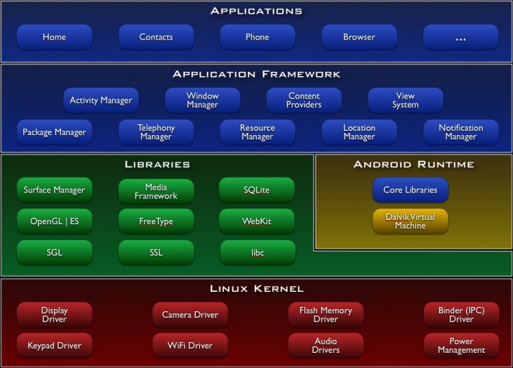

Libraries
Android includes a set of C/C++ libraries used by various components of the Android system. These capabilities are exposed to developers through the Android application framework. Some of the core libraries are listed below:
- System C library - a BSD-derived implementation of the standard C system library (libc), tuned for embedded Linux-based devices
- Media Libraries - based on PacketVideo'sOpenCORE; the libraries support playback and recording of many popular audio and video formats, as well as static image files, including MPEG4, H.264, MP3, AAC, AMR, JPG, and PNG
- Surface Manager - manages access to the display subsystem and seamlessly composites 2D and 3D graphic layers from multiple applications
- LibWebCore - a modern web browser engine which powers both the Android browser and an embeddable web view
- SGL - the underlying 2D graphics engine
- 3D libraries - an implementation based on OpenGL ES 1.0 APIs; the libraries use either hardware 3D acceleration (where available) or the included, highly optimized 3D software rasterizer
- FreeType - bitmap and vector font rendering
- SQLite - a powerful and lightweight relational database engine available to all applicationsAndroid Runtime
Android includes a set of core libraries that provides most of the functionality available in the core libraries of the Java programming language.
Every Android application runs in its own process, with its own instance of the Dalvik virtual machine. Dalvik has been written so that a device can run multiple VMs efficiently. The Dalvik VM executes files in the Dalvik Executable (.dex) format which is optimized for minimal memory footprint. The VM is register-based, and runs classes compiled by a Java language compiler that have been transformed into the .dex format by the included "dx" tool.
The Dalvik VM relies on the Linux kernel for underlying functionality such as threading and low-level memory management.

Linux Kernel

Android relies on Linux version 2.6 for core system services such as security, memory management, process management, network stack, and driver model. The kernel also acts as an abstraction layer between the hardware and the rest of the software stack.
The Linux kernel is an operating system kernel used by the Linux family of Unix-likeoperating systems. It is one of the most prominent examples of free and open source software.
The Linux kernel is released under the GNU General Public License version 2 (GPLv2), (plus some firmware images with various licenses), and is developed by contributors worldwide. Day-to-day development takes place on the Linux kernel mailing list.
The Linux kernel was initially conceived and created by Finnishcomputer science studentLinus Torvalds in 1991. Linux rapidly accumulated developers and users who adapted code from other free software projects for use with the new operating system. The Linux kernel has received contributions from thousands of programmers.^{[10]} Many Linux distributions have been released based upon the Linux kernel.
The Linux kernel has extensive support for and runs on many virtual machine architectures both as the host operating system and as a guest operating system. The virtual machines usually emulate Intel x86 family of processors, though in a few cases PowerPC or ARM processors are also emulated.

At Google, the team led by Rubin developed a mobile device platform powered by the Linux kernel. Google marketed the platform to handset makers and carriers on the premise of providing a flexible, upgradable system. Google had lined up a series of hardware component and software partners and signaled to carriers that it was open to various degrees of cooperation on their part.^{[28][29][30]}
Speculation about Google's intention to enter the mobile communications market continued to build through December 2006.Reports from the BBC and The Wall Street Journal noted that Google wanted its search and applications on mobile phones and it was working hard to deliver that. Print and online media outlets soon reported rumors that Google was developing a Google-branded handset. Some speculated that as Google was defining technical specifications, it was showing prototypes to cell phone manufacturers and network operators.

Hardware running Android
The main supported platform for Android is the ARM architecture.
The Android OS can be used as an operating system for cellphones, netbooks and tablets, including the Dell Streak, Samsung Galaxy Tab, TV and other devices.^{[68][69]} The first commercially available phone to run the Android operating system was the HTC Dream, released on 22 October 2008.^{[70]} In early 2010 Google collaborated with HTC to launch its flagship^{[71]} Android device, the Nexus One. This was followed later in 2010 with the Samsung-made Nexus S.
The early feedback on developing applications for the Android platform was mixed.Issues cited include bugs, lack of documentation, inadequate QA infrastructure, and no public issue-tracking system. (Google announced an issue tracker on 18 January 2008.) In December 2007, MergeLab mobile startup founder Adam MacBeth stated, "Functionality is not there, is poorly documented or just doesn't work... It's clearly not ready for prime time."Despite this, Android-targeted applications began to appear the week after the platform was announced. The first publicly available application was the Snake game The Android Dev Phone is a SIM-unlocked and hardware-unlocked device that is designed for advanced developers. While developers can use regular consumer devices purchased at retail to test and use their applications, some developers may choose not to use a retail device, preferring an unlocked or no-contract device.
The Android software development kit (SDK) includes a comprehensive set of development tools.^{[80]} These include a debugger, libraries, a handset emulator (based on QEMU), documentation, sample code, and tutorials. The SDK is downloadable on the android developer website. Currently supported development platforms include computers running Linux (any modern desktop Linux distribution), Mac OS X 10.4.9 or later, Windows XP or later. The officially supported integrated development environment (IDE) is Eclipse (currently 3.5 or 3.6) using the Android Development Tools (ADT) Plugin, though developers may use any text editor to edit Java and XML files then use command line tools (Java Development Kit and Apache Ant are required) to create, build and debug Android applications as well as control attached Android devices (e.g., triggering a reboot, installing software package(s) remotely).^{[81]}
Android applications are packaged in .apk format and stored under /data/app folder on the Android OS (the folder is accessible to root user only for security reasons). APK package contains .dex files(compiled byte code files called Dalvik executables), resource files, etc.

Android Operation System
Android is an operating system based on Linux with a Java programming interface. It provides tools, e.g. a compiler, debugger and a device emulator as well as its own Java Virtual machine (Dalvik Virtual Machine - DVM). Android is created by the Open Handset Alliance which is lead by Google.
Android uses a special virtual machine, e.g. the Dalvik Virtual Machine. Dalvik uses special bytecode. Therefore you cannot run standard Java bytecode on Android. Android provides a tool "dx" which allows to convert Java Class files into "dex" (Dalvik Executable) files. Android applications are packed into an .apk (Android Package) file by the program "aapt" (Android Asset Packaging Tool) To simplify development Google provides the Android Development Tools (ADT) for Eclipse . The ADT performs automatically the conversion from class to dex files and creates the apk during deployment.
Android supports 2-D and 3-D graphics using the OpenGL libraries and supports data storage in a SQLite database.
Every Android applications runs in its own process and under its own userid which is generated automatically by the Android system during deployment. Therefore the application is isolated from other running applications and a misbehaving application cannot easily harm other Android applications.

Important Android components
An Android application consists out of the following parts:
- Activity - Represents the presentation layer of an Android application, e.g. a screen which the user sees. An Android application can have several activities and it can be switched between them during runtime of the application.
- Views - The User interface of an Activities is build with widgets classes which inherent from "android.view.View". The layout of the views is managed by "android.view.ViewGroups".
- Services - perform background tasks without providing an UI. They can notify the user via the notification framework in Android.
- Content Provider - provides data to applications, via a content provider your application can share data with other applications. Android contains a SQLite DB which can serve as data provider
- Intents are asynchronous messages which allow the application to request functionality from other services or activities. An application can call directly a service or activity (explicit intent) or asked the Android system for registered services and applications for an intent (implicit intents). For example the application could ask via an intent for a contact application. Application register themself to an intent via an IntentFilter. Intents are a powerful concept as they allow to create loosely coupled applications.
- Broadcast Receiver - receives system messages and implicit intents, can be used to react to changed conditions in the system. An application can register as a broadcast receiver for certain events and can be started if such an event occurs.
- A Java Virtual Machine (JVM) enables a set of computer software programs and data structures to use a virtual machine model for the execution of other computer programs and scripts. The model used by a JVM accepts a form of computer intermediate language commonly referred to as Java bytecode. This language conceptually represents the instruction set of a stack-oriented, capability architecture. Sun Microsystems states there are over 4.5 billion JVM-enabled devices
- A JVM can also execute bytecode compiled from programming languages other than Java. For example, Ada source code can be compiled to execute on a JVM. JVMs can also be released by other companies besides Oracle (the developer of Java) — JVMs using the "Java" trademark may be developed by other companies as long as they adhere to the JVM specification published by Oracle and to related contractual obligations.
- Java was conceived with the concept of WORA: "write once, run anywhere". This is done using the Java Virtual Machine. The JVM is the environment in which java programs execute. It is software that is implemented on non-virtual hardware and on standard operating systems.
- JVM is a crucial component of the Java platform, and because JVMs are available for many hardware and software platforms, Java can be both middleware and a platform in its own right,^{[clarification needed]} hence the trademark write once, run anywhere. The use of the same bytecode for all platforms allows Java to be described as "compile once, run anywhere", as opposed to "write once, compile anywhere", which describes cross-platform compiled languages. A JVM also enables such features as automated exception handling, which provides "root-cause" debugging information for every software error (exception), independent of the source code.
- A JVM is distributed along with a set of standard class libraries that implement the Java application programming interface (API). Appropriate APIs bundled together form the Java Runtime Environment (JRE).
- Java's execution environment is termed the Java Runtime Environment, or JRE.
- Programs intended to run on a JVM must be compiled into a standardized portable binary format, which typically comes in the form of .class files. A program may consist of many classes in different files. For easier distribution of large programs, multiple class files may be packaged together in a .jar file (short for Java archive).
- The Java application launcher, java, offers a standard way of executing Java code. Compare javaw.^{[2]}
- The JVM runtime executes .class or .jar files, emulating the JVM instruction set by interpreting it, or using a just-in-time compiler (JIT) such as Oracle's HotSpot. JIT compiling, not interpreting, is used in most JVMs today to achieve greater speed. There are also ahead-of-time compilers that enable developers to precompile class files into native code for particular platforms.
- Like most virtual machines, the Java Virtual Machine has a stack-based architecture akin to a microcontroller/microprocessor. However, the JVM also has low-level support for Java-like classes and methods, which amounts to a highly idiosyncratic^{[clarification needed]}memory model and capability-based architecture.
Download the Android SDK
Welcome Developers! If you are new to the Android SDK, please read the steps below, for an overview of how to set up the SDK.
If you're already using the Android SDK, you should update to the latest tools or platform using the Android SDK and AVD Manager, rather than downloading a new SDK starter package. See Adding SDK Components.

HarisPeco maintains plugins with provides access to the Android Source code. Use the Eclipse update manager to install two of his plugins.

The Android tools include an emulator. This emulator behaves like a real Android device in most cases and allow you to test your application without having a real device. You can emulate one or several devices with different configurations. Each configuration is defined via an "Android Virtual Device" (AVD).
To define an AVD press the device manager button, press "New" and maintain the following.
Press "Create AVD".This will create the device and display it under the "Virtual devices". To test if your setup is correct, select your device and press "Start".

4. Error handling
Things are not always working as they should be. Several users report that get the following errors:
- Project ... is missing required source folder: 'gen'
- The project could not be built until build path errors are resolved.
- Unable to open class file R.java.
To solve this error select from the menu Project -> Clean.
If you having problems with your own code you can use the LogCat viewer as described in LogCat Viewer .

SQL Server 2005
SQL Server 2005 is the successor to SQL Server 2000. It included native support for managing XML data, in addition to relational data. For this purpose, it defined an xml data type that could be used either as a data type in database columns or as literals in queries. XML columns can be associated with XSD schemas. XML data being stored is verified against the schema. XML is converted to an internal binary data type before being stored in the database.
Specialized indexing methods were made available for XML data. XML data is queried using XQuery. Common Language Runtime (CLR) integration was a main feature with this edition, enabling one to write SQL code as Managed Code by the CLR. SQL Server 2005 added some extensions to the T-SQL language to allow embedding XQuery queries in T-SQL. In addition, it also defines a new extension to XQuery, called XML DML that allows query-based modifications to XML data.
SQL Server 2005 also allows a database server to be exposed over web services using Tabular Data Stream (TDS) packets encapsulated within SOAP (protocol) requests. When the data is accessed over web services, results are returned as XML.For relational data, T-SQL has been augmented with error handling features (try/catch) and support for recursive queries with CTEs (Common Table Expressions). SQL Server 2005 has also been enhanced with new indexing algorithms, syntax and better error recovery systems.
Data pages are checksummed for better error resiliency, and optimistic concurrency support has been added for better performance. Permissions and access control have been made more granular and the query processor handles concurrent execution of queries in a more efficient way. Partitions on tables and indexes are supported natively, so scaling out a database onto a cluster is easier. SQL CLR was introduced with SQL Server 2005 to let it integrate with the .NET Framework.
SQL Server 2005 introduced "MARS" (Multiple Active Results Sets), a method of allowing usage of database connections for multiple purposes.SQL Server 2005 introduced DMVs (Dynamic Management Views), which are specialized views and functions that return server state information that can be used to monitor the health of a server instance, diagnose problems, and tune performance.
SQL Server Configuration Manager
SQL Server Configuration Manager is a new tool in SQL Server 2005. It is used to manage SQL Server 2005 services and connections. It has been developed as a Microsoft Management Console (MMC) plug-in application Its window is divided into a Console tree (left pane) and a Details pane. It can be managed through SQL Server services and connection configurations by navigating objects in the Console tree.
Managing Services
- SQL Server
- SQL Server Agent
- SQL Server Browser
- SQL Server Integration Services
- SQL Server Anaylysis Services

SQL Server Management Studio

This tool is a new feature in SQL Server 2005. It replaces Enterprise Manager and Query Analyzer from earlier versions. It has been developed using a Visual Studio shell as a base. It follows the paradigm of Visual Studio, in which most tools are organized as tabbed, dockable, or floating windows.

The registered server’s pane allows viewing and managing parameters for connecting to servers. The tool includes both script editors and graphical tools which work with objects and features of the server.A central feature of SQL Server Management Studio is the Object Explorer, which allows the user to browse, select, and act upon any of the objects within the server.

SQL Server 2005 Features

Database mirroring
- T-SQL (Transaction SQL) enhancements
- CLR integration
- Service Broker

DDL triggers

Ranking functions

Row versioning-based isolation levels

XML integration

TRY...CATCH

Database Mail
- Data encryption
Ease Of Installation, Deployment, And Use
SQL Server includes a set of administrative and development tools that improve ability to install, deploy, manage, and use SQL Server across several sites.

Scalability
The same database engine can be used across platforms ranging from laptop computers running Microsoft Windows® 95/98 to large, multiprocessor servers running Microsoft Windows NT®, Enterprise Edition.
Data Warehousing
SQL Server includes tools for extracting and analyzing summary data for online analytical processing (OLAP). SQL Server also includes tools for visually designing databases and analyzing data using English-based questions. In this project SQL server is used because of the above features.

FEASIBILTY STUDY

The feasibility of the project is analyzed in this phase and business proposal is put forth with a very general plan for the project and some cost estimates. During system analysis the feasibility study of the proposed system is to be carried out. This is to ensure that the proposed system is not a burden to the company. For feasibility analysis, some understanding of the major requirements for the system is essential.
The feasibility study investigates the problem and the information needs of the stakeholders. It seeks to determine the resources required to provide an information systems solution, the cost and benefits of such a solution, and the feasibility of such a solution. The analyst conducting the study gathers information using a variety of methods, the most popular of which are:
- Interviewing users, employees, managers, and customers.
- Developing and administering questionnaires to interested stakeholders, such as potential users of the information system.
- Observing or monitoring users of the current system to determine their needs as well as their satisfaction and dissatisfaction with the current system.
- Collecting, examining, and analyzing documents, reports, layouts, procedures, manuals, and any other documentation relating to the operations of the current system.
- Modeling, observing, and simulating the work activities of the current system.
The goal of the feasibility study is to consider alternative information systems solutions, evaluate their feasibility, and propose the alternative most suitable to the organization. The feasibility of a proposed solution is evaluated in terms of its components. These components are:
- ECONOMICAL FEASIBILITY
- TECHNICAL FEASIBILITY
- SOCIAL FEASIBILITY
- OPERATIONAL FEASIBILITY

ECONOMICAL FEASIBILITY

This study is carried out to check the economic impact that the system will have on the organization. The amount of fund that the company can pour into the research and development of the system is limited. The expenditures must be justified. Thus the developed system as well within the budget and this was achieved because most of the technologies used are freely available. Only the customized products had to be purchased.
TECHNICAL FEASIBILITY

This study is carried out to check the technical feasibility, that is, the technical requirements of the system. Any system developed must not have a high demand on the available technical resources. This will lead to high demands on the available technical resources. This will lead to high demands being placed on the client. The developed system must have a modest requirement, as only minimal or null changes are required for implementing this system.

SOCIAL FEASIBILITY
The aspect of study is to check the level of acceptance of the system by the user. This includes the process of training the user to use the system efficiently. The user must not feel threatened by the system, instead must accept it as a necessity.

The level of acceptance by the users solely depends on the methods that are employed to educate the user about the system and to make him familiar with it. His level of confidence must be raised so that he is also able to make some constructive criticism, which is welcomed, as he is the final user of the system.

OPERATIONAL FEASIBILITY
The ability, desire, and willingness of the stakeholders to use, support, and operate the proposed computer information system. The stakeholders include management, employees, customers, and suppliers. The stakeholders are interested in systems that are easy to operate, make few, if any, errors, produce the desired information, and fall within the objectives of the organization.

SYSTEM DESIGN AND DEVELOPMENT

INPUT DESIGN

Input design is the process of converting user-originated inputs to a computer-based format. Input design is one of the most expensive phases of the operation of computerized system and is often the major problem of a system.
In the project, the input design is made in various web forms with various methods.
For example, in the user creation form, the empty username and password is not allowed. The username if exists in the database, the input is considered to be invalid and is not accepted.
Likewise, during the login process, the username is a must and must be available in the user list in the database. Then only login is allowed.
Input forms are
User registration
Booking

OUTPUT DESIGN

Output design generally refers to the results and information that are generated by the system for many end-users; output is the main reason for developing the system and the basis on which they evaluate the usefulness of the application.
In the project, the user details, the web log, are the web forms in which the output is available.
Outputs are
View Booking
View Users

DATABASE DESIGN

The database design is a must for any application developed especially more for the data store projects. Since the chatting method involves storing the message in the table and produced to the sender and receiver, proper handling of the table is a must. In the project, login table is designed to be unique in accepting the username and the length of the username and password should be greater than zero. The different users view the data in different format according to the privileges given.

Tables
Customer
Primary key:Userid
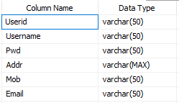
Service
Primary key:Sid
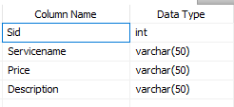
Booking
Primary key:Bid
Foreignkey:Userid,Sid
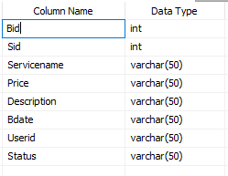

DATA FLOW DIAGRAM

Level 0:

Car Washing App
DB
User’s
Admin

level 1

Login
Login
add
Service
Admin
Service
View
Appointment
Customer
Booking

Level 2:
User
Login
Book
Booking

Customer
View
Service

ER DIAGRAM
sname
Service id
Post
View
Uname
pwd
Uid
addr
Process
price
Uid
Service
sid
date
View
Customer
Booking

Admin
Service

TESTING

Test Case Design
One of the most important phases in the development of any software is testing. Testing is a dynamic technique of verification and validation, which ensures that the software meets the expectations of the user. It involves executing an implementation of the software with test data. Test data is the set of data that the system will process as a normal input. A test case is a set of sequential steps to execute a test, operating on a set of predefined inputs to produce certain expected outputs.
Testing demonstrates the software functions work according to specifications. In addition data collected from testing provides a good indication of software reliability and quality. Testing results in the deduction of number of errors. In this project critical modules are tested. The fields are tested for various validation methods using the different testing techniques.

Test objectives
- All field entries must work properly.
- Pages must be activated from the identified link.
- The entry screen, messages and responses must not be delayed.
- Features to be tested
- Verify that the entries are of the correct format
- No duplicate entries should be allowed
- All links should take the user to the correct page.

Introduction
The most important phase in system development life cycle is system testing. The number and nature of errors in a newly designed system depends on the system specifications and the time frame given for the design.
A newly designed system should have all the subsystems working together, but in reality each subsystems work independently. During this phase, all the subsystems are gathered into one pool and tested to determine whether it meets the user requirements.
Testing is done at two level -Testing of individual modules and testing the entire system. During the system testing, the system is used experimentally to ensure that the software will run according to the specifications and in the way the user expects. Each test case is designed with the intent of finding errors in the way the system will process it.
Testing plays a very critical role in determining the reliability and efficiency of software and hence is a very important stage in software development. Software testing is done at different levels. They are the unit testing and system testing which comprises of integration testing and acceptance testing.
TYPES OF TESTING
Unit Testing
This is the first level of testing. The different modules are tested against the specifications produced during the integration. This is done to test the internal logic of each module. Those resulting from the interaction between modules are initially avoided. The input received and output generated is also tested to see whether it falls in the expected range of values. Unit testing is performed from the bottom up, starting with the smallest and lowest modules and proceeding one at a time.

The units in a system are the modules and routines that are assembled and integrated to perform a specific function. The programs are tested for correctness of logic applied and detection of errors in coding. Each of the modules was tested and errors are rectified. They were then found to function properly.
Integration Testing
In integration testing, the tested modules are combined into sub-systems, which are then tested. The goal of integration testing to check whether the modules can be integrated properly emphasizing on the interfaces between modules. The different modules were linked together and integration testing done on them.
Validation Testing
The objective of the validation test is to tell the user about the validity and reliability of the system. It verifies whether the system operates as specified and the integrity of important data is maintained. User motivation is very important for the successful performance of the system.
All the modules were tested individually using both test data and live data. After each module was ascertained that it was working correctly and it had been "integrated" with the system. Again the system was tested as a whole. We hold the system tested with different types of users. The System Design, Data Flow Diagrams, procedures etc. were well documented so that the system can be easily maintained and upgraded by any computer professional at a later
System Testing
The integration of each module in the system is checked during this level of testing. The objective of system testing is to check if the software meets its requirements. System testing is done to uncover errors that were not found in earlier tests. This includes forced system failures and validation of total system as the user in the operational environment implements it. Under this testing, low volumes of transactions are generally based on live data. This volume is increased until the maximum level for each transactions type is reached. The total system is also tested for recovery after various major failures to ensure that no data are lost during the breakdown.
User Acceptance Testing
The objective of the acceptance test is to tell the user about the validity and reliability of the system. It verifies whether the system operates as specified and the integrity of important data is maintained. User motivation is very important for the successful performance of the system.
All the modules were tested individually using both test data and live data. After each module was ascertained that it was working correctly and it had been "integrated" with the system. Again the system was tested as a whole. We hold the system tested with different types of users. The System Design, Data Flow Diagrams, procedures etc. were well documented so that the system can be easily maintained and upgraded by any computer professional at a later

SYSTEM Implementation
Implementation is the process that actually yields the lowest-level system elements in the system hierarchy (system breakdown structure). The system elements are made, bought, or reused. Production involves the hardware fabrication processes of forming, removing, joining, and finishing; or the software realization processes of coding and testing; or the operational procedures development processes for operators' roles. If implementation involves a production process, a manufacturing system which uses the established technical and management processes may be required.
The purpose of the implementation process is to design and create (or fabricate) a system element conforming to that element’s design properties and/or requirements. The element is constructed employing appropriate technologies and industry practices. This process bridges the system definition processes and the integration process.
System Implementation is the stage in the project where the theoretical design is turned into a working system. The most critical stage is achieving a successful system and in giving confidence on the new system for the user that it will work efficiently and effectively. The existing system was long time process.
The proposed system was developed using Android. The existing system caused long time transmission process but the system developed now has a very good user-friendly tool, which has a menu-based interface, graphical interface for the end user. After coding and testing, the project is to be installed on the necessary system. The executable file is to be created and loaded in the system. Again the code is tested in the installed system. Installing the developed code in system in the form of executable file is implementation.

CONCLUSION
It is concluded that the application works well and satisfy the end users. The application is tested very well and errors are properly debugged. The application is simultaneously accessed from more than one system. Simultaneous login from more than one place is tested.

This system is user friendly so everyone can use easily. Proper documentation is provided. The end user can easily understand how the whole system is implemented by going through the documentation. The system is tested, implemented and the performance is found to be satisfactory. All necessary output is generated. Thus, the project is completed successfully.
Further enhancements can be made to the application, so that the application functions very attractive and useful manner than the present one. The speed of the transactions become more enough now.
SCOPE FOR FUTUREWORK:-
There is scope for future development of this project. The world of computer fields is not static; it is always subject to be dynamic. The technology which is famous today becomes outdated the very next day. To keep abstract of technical improvements, the system may be further refined. So, it is not concluded. Yet it will improve with further enhancements.
Enhancements can be done in an efficient manner. In our future work we will implement our system with three search engines ( for eg Google, bing, yahoo).So that the user can obtain very best results .

BIBLIOGRAPHY

Textual Reference
- "Android App Stats". Archived from the original on January 2, 2011. Retrieved December 31, 2010.
- appfour. "AIDE- IDE for Android Java C++ - Android Apps on Google Play".
- "Android Debug Bridge | Android Developers" Accessed December 27, 2012
- "Accessory Development Kit | Android Developers". Developer.android.com. Retrieved October 2, 2012.
- "MIT Launches New Center for Mobile Learning". August 16, 2011.
- "App Inventor Classic | Explore MIT App Inventor". Appinventor.mit.edu. December 3, 2013. Retrieved March 13, 2014.

Online Reference

- developer.android.com
- en.wikipedia.org
- www.techspot.com
- docs.unity3d.com
- www.openhandsetalliance.com
Screens

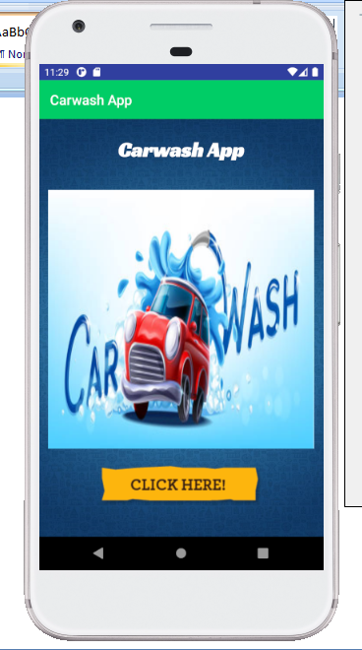

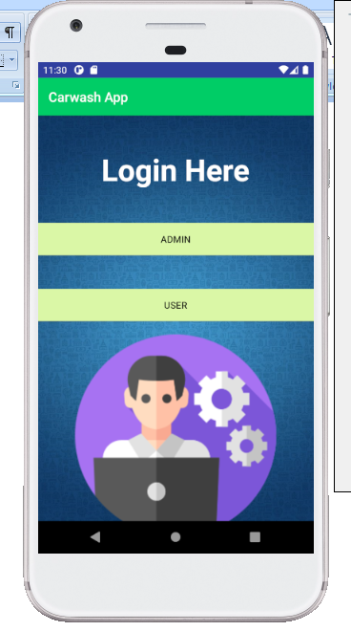

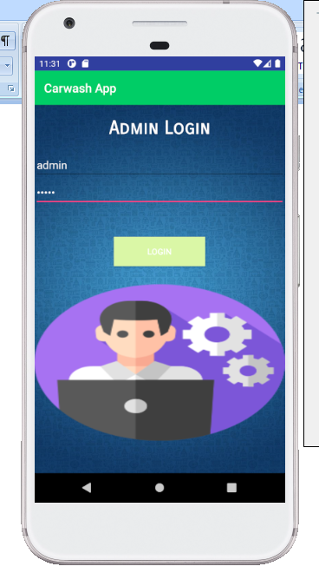

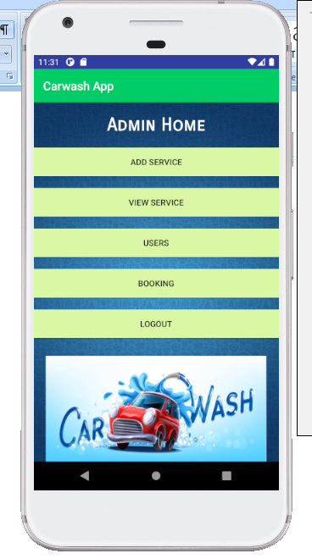

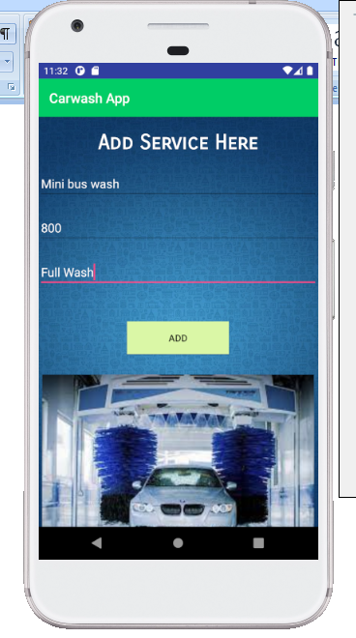

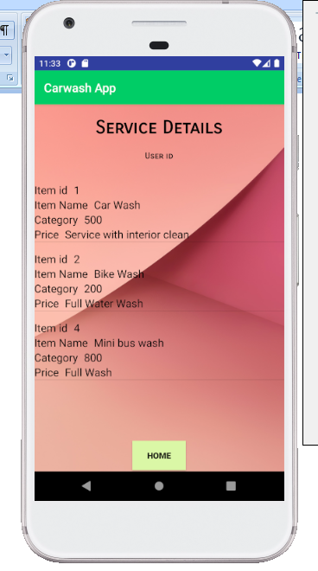

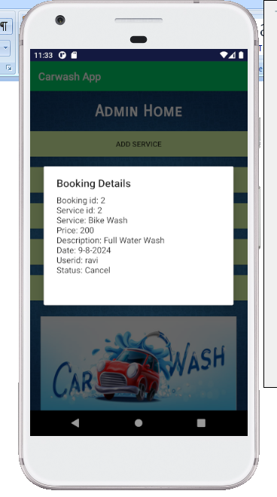

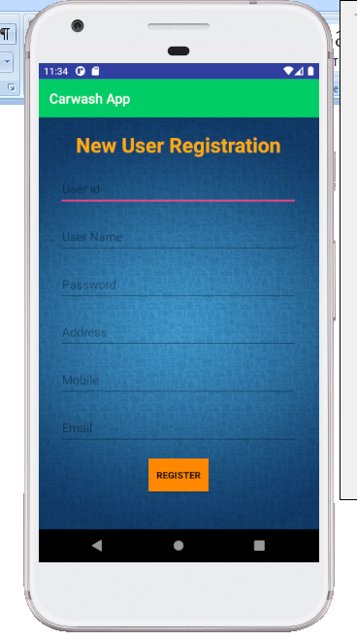

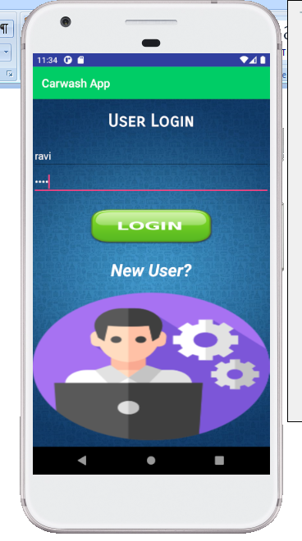

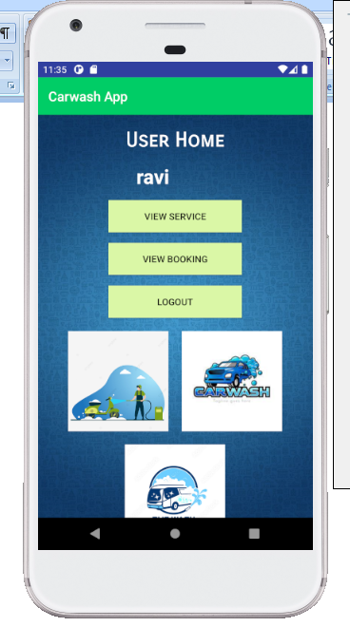

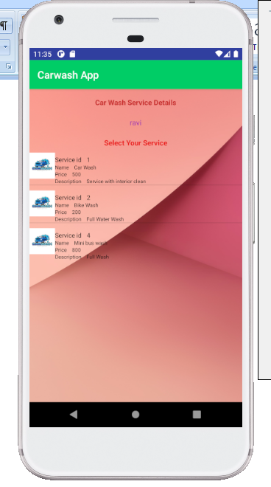

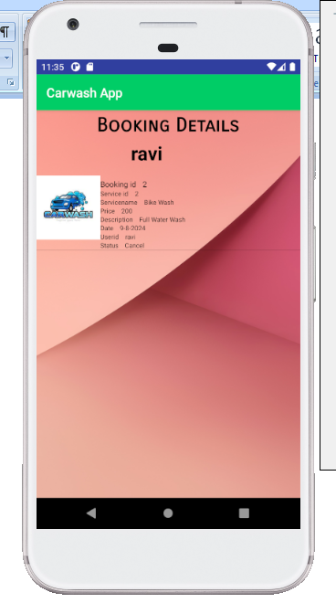
Coding

package com.example.dell_pc.libraryproject;
import android.content.Intent;
import android.os.StrictMode;
import android.support.v7.app.AppCompatActivity;
import android.os.Bundle;
import android.view.View;
import android.widget.EditText;
import android.widget.Toast;
public class Userreg extends AppCompatActivity {
EditText e1,e2,e3,e4,e5,e6;
@Override
protected void onCreate(Bundle savedInstanceState) {
super.onCreate(savedInstanceState);
setContentView(R.layout.activity_userreg);
e1 = (EditText) findViewById(R.id.editText5);
e2 = (EditText) findViewById(R.id.editText6);
e3 = (EditText) findViewById(R.id.editText9);
e4 = (EditText) findViewById(R.id.editText10);
e5 = (EditText) findViewById(R.id.editText12);
e6 = (EditText) findViewById(R.id.editText13);
}
public void sregi(View arg)
{
if (android.os.Build.VERSION.SDK_INT >= 9) {
StrictMode.ThreadPolicy policy = new StrictMode.ThreadPolicy.Builder().permitAll().build();
StrictMode.setThreadPolicy(policy);
}
try {
Boolean loginStatus = WebService.Newusers(e1.getText().toString(),e2.getText().toString(),e3.getText().toString(),e4.getText().toString(),e5.getText().toString(),e6.getText().toString(),"Newuser");
Toast.makeText(Userreg.this, "Register Successfully", Toast.LENGTH_LONG).show();
Intent i = new Intent(Userreg.this, userlogin.class);
startActivity(i);
}
catch (Exception e)
{
Toast.makeText(Userreg.this, "Exception", Toast.LENGTH_LONG).show();
}
}
}
package com.example.dell_pc.libraryproject;
import android.content.Context;
import android.content.Intent;
import android.os.StrictMode;
import android.support.v7.app.AppCompatActivity;
import android.os.Bundle;
import android.view.LayoutInflater;
import android.view.View;
import android.view.ViewGroup;
import android.widget.AdapterView;
import android.widget.ArrayAdapter;
import android.widget.BaseAdapter;
import android.widget.EditText;
import android.widget.GridView;
import android.widget.ImageView;
import android.widget.ListView;
import android.widget.Spinner;
import android.widget.TextView;
import android.widget.AdapterView.OnItemClickListener;
import android.widget.Toast;
import android.app.DatePickerDialog;
import android.widget.Button;
import android.widget.DatePicker;
import android.widget.TextView;
import java.util.Calendar;
public class Booking extends AppCompatActivity {
EditText e1,e2,e3,e4;
TextView t1,t2;
String usern,serid;
public GridView data;
TextView tv;
// String usern;
public ListView lv;
public String login;
public int rowcount=0;
private Button pickDateBtn;
private TextView selectedDateTV;
@Override
protected void onCreate(Bundle savedInstanceState) {
super.onCreate(savedInstanceState);
setContentView(R.layout.activity_booking);
try {
Intent ii = getIntent();
t1 = (TextView) findViewById(R.id.textView27);
t2 = (TextView) findViewById(R.id.textView28);
e1 = (EditText) findViewById(R.id.editText16);
e2 = (EditText) findViewById(R.id.editText17);
e3 = (EditText) findViewById(R.id.editText18);
e4 = (EditText) findViewById(R.id.editText19);
usern = ii.getStringExtra("userid");
serid = ii.getStringExtra("Servid");
t1.setText(usern);
t2.setText(serid);
//
if (android.os.Build.VERSION.SDK_INT >= 9) {
StrictMode.ThreadPolicy policy = new StrictMode.ThreadPolicy.Builder().permitAll().build();
StrictMode.setThreadPolicy(policy);
}
//
login=WebService.Viewserv(t2.getText().toString(),"Viewser");
String[] str=login.split(",");
if(str[0].equals("ok"))
{
String sid=str[1].toString();
String sname=str[2].toString();
String price=str[3].toString();
String des=str[4].toString();
e1.setText(sid);
e2.setText(sname);
e3.setText(price);
e4.setText(des);
}
else
{
Toast.makeText(getApplication(),"No Data",Toast.LENGTH_SHORT).show();
}
//
}
catch (Exception e)
{
Toast.makeText(getApplication(),"No Data",Toast.LENGTH_SHORT).show();
}
//
// on below line we are initializing our variables.
pickDateBtn = findViewById(R.id.idBtnPickDate);
selectedDateTV = findViewById(R.id.idTVSelectedDate);
// on below line we are adding click listener for our pick date button
pickDateBtn.setOnClickListener(new View.OnClickListener() {
@Override
public void onClick(View v) {
// on below line we are getting
// the instance of our calendar.
final Calendar c = Calendar.getInstance();
// on below line we are getting
// our day, month and year.
int year = c.get(Calendar.YEAR);
int month = c.get(Calendar.MONTH);
int day = c.get(Calendar.DAY_OF_MONTH);
// on below line we are creating a variable for date picker dialog.
DatePickerDialog datePickerDialog = new DatePickerDialog(
// on below line we are passing context.
Booking.this,
new DatePickerDialog.OnDateSetListener() {
@Override
public void onDateSet(DatePicker view, int year,
int monthOfYear, int dayOfMonth) {
// on below line we are setting date to our text view.
selectedDateTV.setText(dayOfMonth + "-" + (monthOfYear + 1) + "-" + year);
}
},
// on below line we are passing year,
// month and day for selected date in our date picker.
year, month, day);
// at last we are calling show to
// display our date picker dialog.
datePickerDialog.show();
}
});
//
}
public void goh(View arg)
{
Intent i = new Intent(this, Userhome.class);
i.putExtra("userid",t1.getText().toString());
startActivity(i);
}
public void Bookh(View arg)
{
if (android.os.Build.VERSION.SDK_INT >= 9) {
StrictMode.ThreadPolicy policy = new StrictMode.ThreadPolicy.Builder().permitAll().build();
StrictMode.setThreadPolicy(policy);
}
try {
Boolean loginStatus = WebService.Bookinghere(e1.getText().toString(),e2.getText().toString(),e3.getText().toString(),e4.getText().toString(),selectedDateTV.getText().toString(),t1.getText().toString(), "Booking");
Toast.makeText(this, "Added Successfully", Toast.LENGTH_LONG).show();
}
catch (Exception e)
{
Toast.makeText(this, "Exception", Toast.LENGTH_LONG).show();
}
}
}

Webservice
public static String invokeLoginWS(String p1,String p2,String webMethName) {
String loginStatus ="";
// Create request
SoapObject request = new SoapObject(NAMESPACE, webMethName);
// Property which holds input parameters
PropertyInfo unamePI = new PropertyInfo();
PropertyInfo passPI = new PropertyInfo();

// Set Username
unamePI.setName("Staffid");
// Set Value
unamePI.setValue(p1);
// Set dataType
unamePI.setType(String.class);
// Add the property to request object
request.addProperty(unamePI);

passPI.setName("pwd");
// Set Value
passPI.setValue(p2);
// Set dataType
passPI.setType(String.class);
// Add the property to request object
request.addProperty(passPI);
// Create envelope
SoapSerializationEnvelope envelope = new SoapSerializationEnvelope(
SoapEnvelope.VER11);
envelope.dotNet = true;
// Set output SOAP object
envelope.setOutputSoapObject(request);
// Create HTTP call object
HttpTransportSE androidHttpTransport = new HttpTransportSE(URL);

try {
// Invoke web service
androidHttpTransport.call(SOAP_ACTION+webMethName, envelope);
// Get the response
SoapPrimitive response = (SoapPrimitive) envelope.getResponse();
// Assign it to boolean variable variable
loginStatus = response.toString();

} catch (Exception e) {
//Assign Error Status true in static variable 'errored'

e.printStackTrace();
}
//Return booleam to calling object
return loginStatus;
}

public static boolean Newuserreg(String v1,String v2,String v3,String v4,String v5,String v6, String webMethName) {
boolean loginStatus = false;
// Create request
SoapObject request = new SoapObject(NAMESPACE, webMethName);
// Property which holds input parameters
PropertyInfo p1 = new PropertyInfo();
PropertyInfo p2 = new PropertyInfo();
PropertyInfo p3 = new PropertyInfo();
PropertyInfo p4 = new PropertyInfo();
PropertyInfo p5 = new PropertyInfo();
PropertyInfo p6= new PropertyInfo();

p1.setName("Userid");//dotnet webservice code string
p1.setValue(v1);//in this code string variable
p1.setType(String.class);
request.addProperty(p1);

p2.setName("Username");
p2.setValue(v2);
p2.setType(String.class);
request.addProperty(p2);

p3.setName("Pwd");
p3.setValue(v3);
p3.setType(String.class);
request.addProperty(p3);

p4.setName("Addr");
p4.setValue(v4);
p4.setType(String.class);
request.addProperty(p4);

p5.setName("Mob");
p5.setValue(v5);
p5.setType(String.class);
request.addProperty(p5);

p6.setName("Email");
p6.setValue(v6);
p6.setType(String.class);
request.addProperty(p6);

// Create envelope
SoapSerializationEnvelope envelope = new SoapSerializationEnvelope(
SoapEnvelope.VER11);
envelope.dotNet = true;
// Set output SOAP object
envelope.setOutputSoapObject(request);
// Create HTTP call object
HttpTransportSE androidHttpTransport = new HttpTransportSE(URL);

try {
// Invoke web service
androidHttpTransport.call(SOAP_ACTION+webMethName, envelope);
// Get the response
SoapPrimitive response = (SoapPrimitive) envelope.getResponse();
// Assign it to boolean variable variable
loginStatus = Boolean.parseBoolean(response.toString());

} catch (Exception e) {
//Assign Error Status true in static variable 'errored'

e.printStackTrace();
}
//Return booleam to calling object
return loginStatus;
}

public static String Viewserv(String p1,String webMethName) {
String loginStatus ="";
// Create request
SoapObject request = new SoapObject(NAMESPACE, webMethName);
// Property which holds input parameters
PropertyInfo unamePI = new PropertyInfo();
PropertyInfo passPI = new PropertyInfo();

// Set Username
unamePI.setName("Servid");
// Set Value
unamePI.setValue(p1);
// Set dataType
unamePI.setType(String.class);
// Add the property to request object
request.addProperty(unamePI);

// Create envelope
SoapSerializationEnvelope envelope = new SoapSerializationEnvelope(
SoapEnvelope.VER11);
envelope.dotNet = true;
// Set output SOAP object
envelope.setOutputSoapObject(request);
// Create HTTP call object
HttpTransportSE androidHttpTransport = new HttpTransportSE(URL);

try {
// Invoke web service
androidHttpTransport.call(SOAP_ACTION+webMethName, envelope);
// Get the response
SoapPrimitive response = (SoapPrimitive) envelope.getResponse();
// Assign it to boolean variable variable
loginStatus = response.toString();

} catch (Exception e) {
//Assign Error Status true in static variable 'errored'

e.printStackTrace();
}
//Return booleam to calling object
return loginStatus;
}

public static String Ordersdet(String v1, String webMethName) {
String loginStatus ="";
// Create request
SoapObject request = new SoapObject(NAMESPACE, webMethName);
// Property which holds input parameters
PropertyInfo p1 = new PropertyInfo();

p1.setName("res");//dotnet webservice code string
p1.setValue(v1);//in this code string variable
p1.setType(String.class);
request.addProperty(p1);

// Create envelope
SoapSerializationEnvelope envelope = new SoapSerializationEnvelope(
SoapEnvelope.VER11);
envelope.dotNet = true;
// Set output SOAP object
envelope.setOutputSoapObject(request);
// Create HTTP call object
HttpTransportSE androidHttpTransport = new HttpTransportSE(URL);

try {
// Invoke web service
androidHttpTransport.call(SOAP_ACTION+webMethName, envelope);
// Get the response
SoapPrimitive response = (SoapPrimitive) envelope.getResponse();
// Assign it to boolean variable variable
loginStatus = response.toString();

} catch (Exception e) {
//Assign Error Status true in static variable 'errored'

e.printStackTrace();
}
//Return booleam to calling object
return loginStatus;
}

public static boolean cancelbooking(String v1, String webMethName) {
boolean loginStatus = false;
// Create request
SoapObject request = new SoapObject(NAMESPACE, webMethName);
// Property which holds input parameters
PropertyInfo p1 = new PropertyInfo();

p1.setName("Bid");//dotnet webservice code string
p1.setValue(v1);//in this code string variable
p1.setType(String.class);
request.addProperty(p1);

// Create envelope
SoapSerializationEnvelope envelope = new SoapSerializationEnvelope(
SoapEnvelope.VER11);
envelope.dotNet = true;
// Set output SOAP object
envelope.setOutputSoapObject(request);
// Create HTTP call object
HttpTransportSE androidHttpTransport = new HttpTransportSE(URL);

try {
// Invoke web service
androidHttpTransport.call(SOAP_ACTION+webMethName, envelope);
// Get the response
SoapPrimitive response = (SoapPrimitive) envelope.getResponse();
// Assign it to boolean variable variable
loginStatus = Boolean.parseBoolean(response.toString());

} catch (Exception e) {
//Assign Error Status true in static variable 'errored'

e.printStackTrace();
}
//Return booleam to calling object
return loginStatus;
}

public static boolean updatereq(String v1,String v2, String webMethName) {
boolean loginStatus = false;
// Create request
SoapObject request = new SoapObject(NAMESPACE, webMethName);
// Property which holds input parameters
PropertyInfo p1 = new PropertyInfo();
PropertyInfo p2 = new PropertyInfo();

p1.setName("reqid");//dotnet webservice code string
p1.setValue(v1);//in this code string variable
p1.setType(String.class);
request.addProperty(p1);

p2.setName("repl");
p2.setValue(v2);
p2.setType(String.class);
request.addProperty(p2);

// Create envelope
SoapSerializationEnvelope envelope = new SoapSerializationEnvelope(
SoapEnvelope.VER11);
envelope.dotNet = true;
// Set output SOAP object
envelope.setOutputSoapObject(request);
// Create HTTP call object
HttpTransportSE androidHttpTransport = new HttpTransportSE(URL);

try {
// Invoke web service
androidHttpTransport.call(SOAP_ACTION+webMethName, envelope);
// Get the response
SoapPrimitive response = (SoapPrimitive) envelope.getResponse();
// Assign it to boolean variable variable
loginStatus = Boolean.parseBoolean(response.toString());

} catch (Exception e) {
//Assign Error Status true in static variable 'errored'

e.printStackTrace();
}
//Return booleam to calling object
return loginStatus;
}

public static String vstatus(String username,String webMethName) {
String loginStatus ="";
// Create request
SoapObject request = new SoapObject(NAMESPACE, webMethName);
// Property which holds input parameters
PropertyInfo unamePI = new PropertyInfo();
PropertyInfo passPI = new PropertyInfo();

// Set Username
unamePI.setName("res");
// Set Value
unamePI.setValue(username);
// Set dataType
unamePI.setType(String.class);
// Add the property to request object
request.addProperty(unamePI);

// Create envelope
SoapSerializationEnvelope envelope = new SoapSerializationEnvelope(
SoapEnvelope.VER11);
envelope.dotNet = true;
// Set output SOAP object
envelope.setOutputSoapObject(request);
// Create HTTP call object
HttpTransportSE androidHttpTransport = new HttpTransportSE(URL);

try {
// Invoke web service
androidHttpTransport.call(SOAP_ACTION+webMethName, envelope);
// Get the response
SoapPrimitive response = (SoapPrimitive) envelope.getResponse();
// Assign it to boolean variable variable
loginStatus = response.toString();

} catch (Exception e) {
//Assign Error Status true in static variable 'errored'

e.printStackTrace();
}
//Return booleam to calling object
return loginStatus;
}

public static String vpay(String username,String webMethName) {
String loginStatus ="";
// Create request
SoapObject request = new SoapObject(NAMESPACE, webMethName);
// Property which holds input parameters
PropertyInfo unamePI = new PropertyInfo();
PropertyInfo passPI = new PropertyInfo();

// Set Username
unamePI.setName("res");
// Set Value
unamePI.setValue(username);
// Set dataType
unamePI.setType(String.class);
// Add the property to request object
request.addProperty(unamePI);

// Create envelope
SoapSerializationEnvelope envelope = new SoapSerializationEnvelope(
SoapEnvelope.VER11);
envelope.dotNet = true;
// Set output SOAP object
envelope.setOutputSoapObject(request);
// Create HTTP call object
HttpTransportSE androidHttpTransport = new HttpTransportSE(URL);

try {
// Invoke web service
androidHttpTransport.call(SOAP_ACTION+webMethName, envelope);
// Get the response
SoapPrimitive response = (SoapPrimitive) envelope.getResponse();
// Assign it to boolean variable variable
loginStatus = response.toString();

} catch (Exception e) {
//Assign Error Status true in static variable 'errored'

e.printStackTrace();
}
//Return booleam to calling object
return loginStatus;
}

public static String Viewbbokingad(String username,String webMethName) {
String loginStatus ="";
// Create request
SoapObject request = new SoapObject(NAMESPACE, webMethName);
// Property which holds input parameters
PropertyInfo unamePI = new PropertyInfo();
PropertyInfo passPI = new PropertyInfo();

// Set Username
unamePI.setName("res");
// Set Value
unamePI.setValue(username);
// Set dataType
unamePI.setType(String.class);
// Add the property to request object
request.addProperty(unamePI);

// Create envelope
SoapSerializationEnvelope envelope = new SoapSerializationEnvelope(
SoapEnvelope.VER11);
envelope.dotNet = true;
// Set output SOAP object
envelope.setOutputSoapObject(request);
// Create HTTP call object
HttpTransportSE androidHttpTransport = new HttpTransportSE(URL);

try {
// Invoke web service
androidHttpTransport.call(SOAP_ACTION+webMethName, envelope);
// Get the response
SoapPrimitive response = (SoapPrimitive) envelope.getResponse();
// Assign it to boolean variable variable
loginStatus = response.toString();

} catch (Exception e) {
//Assign Error Status true in static variable 'errored'

e.printStackTrace();
}
//Return booleam to calling object
return loginStatus;
}

